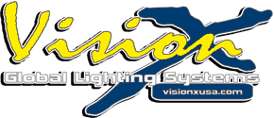

New End Cap Mounts For The XPR and XPI Series LED Light Bars

Perfect For Mounting On Roofs Or In Bumpers!
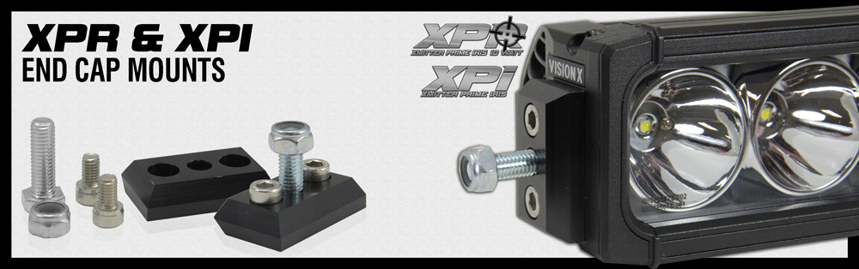
July 2nd, 2015 – Vision X Lighting is excited to announce the release of End Cap Mounts for the XPR and XPI series LED Light Bars. These slim end cap mounts allow XPR/XPI owners to directly mount their light bar from the side, properly centering and balancing the light bar. This pair of billet End Cap mounts comes with all hardware necessary to bolt your light up using a vertical tab mount and not the feet that are included with every light. Perfect for mounting on the roof or in bumpers, these end cap mounts open up many different mounting options.
These End Caps use two bolts to attach to each end of the light bar, and then a large fitted bolt with a powerful seal nut extends from the cap. The bolts on the top and bottom of the end cap allow for a secured mount, eliminating vibration and ensuring the light bar remains mounted in even the toughest of applications.
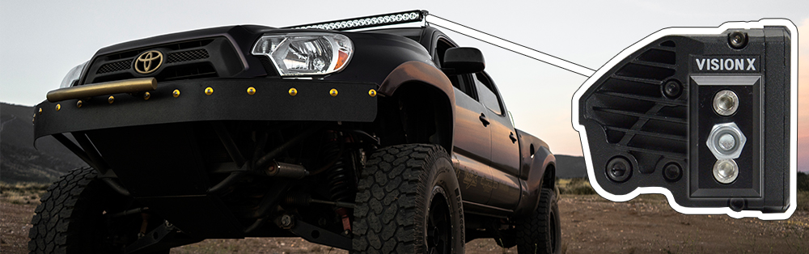

XPI/XPR End Cap Mounts Features:
- Securely Mount XPI/XPR LED Light Bars Directly From Bar Ends
- Full Billet Aluminum Construction, Black Anodize
- Works With All Sizes Of XPR/XPI LED Light Bars
- Great For Roof Or Bumper Mounted Applications
- Maintains Light Bars Original Appearance
- Double Bolts Ensure Secured Mount
- Sealed Nut For Tight Seal
XPR/XPI End Cap Mounts
Item Number | Part # | Description | Jobber
XPI-EM | 9892917 | PAIR OF XPI/XPR END CAP MOUNTS | $49.00
For more information please visit www.visionxusa.com or call 888-489-9820
###
Vision X Lighting, located in Seattle, Washington, was established in 1997 with the mission to revolutionize the lighting industry. Since that time, Vision X Lighting has created one of the largest premium lighting offerings in the world with hundreds of products and applications. The military, border patrol, and even NASA have trusted Vision X Lighting on vehicles that cannot work with second best. Vision X Lighting has lead the lighting industry growing 759% in the past 3 years which placed them on the 2012 INC 5000 list at 503, 10th overall in manufacturing and 10th in the Seattle Washington area. Vision X Lighting's commitment to its customers, dealers and product is unsurpassed. www.visionxusa.com

